Genevieve McNeil
01/30/25
IS 5203 Lab #0 Mininet and Wireshark Setup
Mininet (http://mininet.org/) creates a realistic virtual network, running real kernel, switch, and application code on a single machine (VM, cloud, or native) in seconds. In this course, we will use Mininet to design and simulate networks programmatically. Therefore, setting up the environment correctly and being familiar with the tool will be critical at the early stage of this course.
Lab objectives:
- Install Mininet on your (virtual) machine
- Explore the default network provided by Mininet
- Conduct initial packet capture using Wireshark
Submission Instruction:
- Fill your answers to this instruction (in the spaces after each deliverable, attach a screenshot in place where you can find a [Screenshot] label.)
- Save the file in .doc/.docx/.pdf format and upload it to the Canvas item where you downloaded this instruction.

Install Mininet (10 pts)
We recommend that you install Mininet on a Virtual Machine to avoid any potential disruption of your daily work.
1. Virtualization Tool Download & Installation.
For this course, VirtualBox (https://www.virtualbox.org/wiki/Downloads) is recommended as it is available for free on all platforms (Win, Mac (x86), Linux). However, please feel free to use VMWare, Parallel, or other virtual machine software if you prefer.
- Q: VirtualBox cannot load the kernel on macOS (MacBook x86).
- A: After you have installed the application (within 30 minutes), go to the Security & Privacy settings and allow Oracle product to run on your machine.
If you have a Mac with Apple Silicon (e.g., M1/M2/M3/M4), please first try installing VirtualBox 7.0.8 Developer Preview for macOS / Arm64 (M1/M2) hosts (click the link to download). If it doesn’t work, please identify other appropriate virtualization software, as VirtualBox is not backporting enhancements and fixes to the 7.0 branch for ARM platforms.
- https://apple.stackexchange.com/questions/422565/does-virtualbox-run-on-apple-silicon
- https://www.virtualbox.org/ticket/21771
2. Mininet Download & Installation.
We will be running Wireshark GUI together with Mininet. Therefore, it is recommended that you have both GUI and Mininet in your system.
2.1 Mininet system image
Please download Mininet’s image (based on Ubuntu 20.04) and import it to your VirtualBox.
- Setup guide: http://mininet.org/vm-setup-notes/
- The Mininet 2.3.0 Image to download (click this link to download):
  - https://github.com/mininet/mininet/releases/download/2.3.0/mininet-2.3.0-210211-ubuntu-20.04.1-legacy-server-amd64-ovf.zip
- Username/password: mininet/mininet
Unzip the file to the location you select and use the Import Appliance function to load the downloaded VM image (appliance) into VirtualBox. Make sure that you import the “.ovf” file.
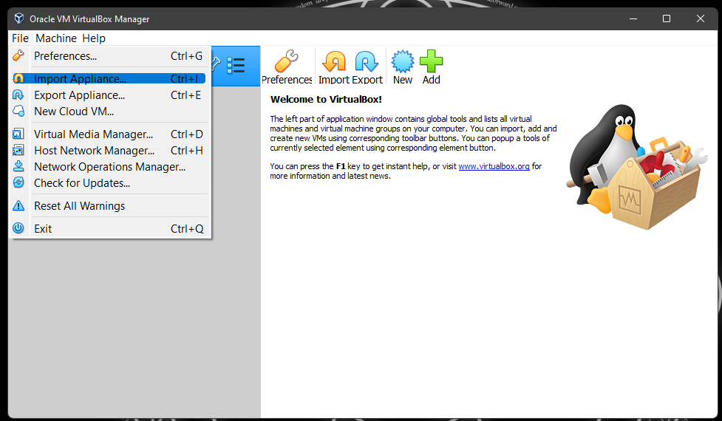
After importing the VM image, navigate to the machine settings, and under Storage-Storage Devices, select “add optical drive” (a small logo next to “Controller: SCSI”).
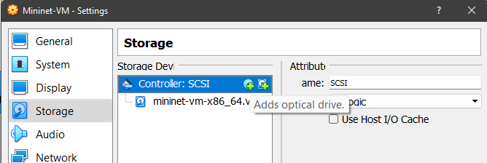
We will use this optical drive to install the VirtualBox Guest Additional CD later.
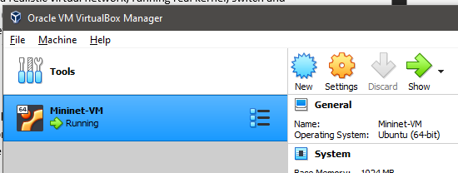
- You can leave the optical drive empty (bottom right button).
  - Make sure that you see “SCSI Port 1: [Optical Drive] Empty” on the summary page under the Storage section.
- Most modern machines are powerful; please allocate more resources to the virtual machine for a better user experience:
  - CPU (1🡪2)
  - Memory (1024 MB 🡪 2048/4096 MB)
  - Video memory (16 MB 🡪 32/64 MB)
  - Graphics Controller (VBoxVGA 🡪 VMSVGA, enabling 3D acceleration)
Boot the virtual machine and install the GUI.

- If the virtual machine captures your mouse cursor, you can escape by pressing the “Host Key” shown at the bottom right of the VM window (for Windows, by default, it’s Right Ctrl).
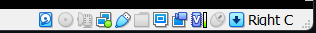
- Before executing the following commands, make sure that you have a stable network.
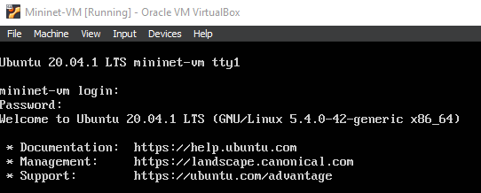
- After logging in to the system (with mininet/mininet), make sure the system version is Ubuntu 20.04.1 LTS.
- Run “sudo apt update” to update the software package manager.
- It is recommended that you install “xfce4” as your GUI as it’s lightweight.
  - Run “sudo apt install xfce4” to download and install the package.
  - When selecting the “Display Manager,” you can press the “Down Arrow Key” to select “lightdm” and press “Enter” to install it, as this tool is lighter weight and less resource-demanding compared to “gdm3.”
- Run “sudo apt install xfce4-terminal” to install a more modern-looking terminal instead of the default “UXTerm.”
- After installing the GUI, use “sudo reboot” to restart the machine.
When you see the Ubuntu 20.04 LTS login page, please click on the Ubuntu icon (the one in the upper right corner, in the red box, as shown in the image below) above the password field, and select “Xfce Session” before you type the password and log into the system.
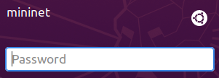

After you log into the GUI system, you can install VirtualBox Guest Additional CD to enable resolution adaption and other functionalities:
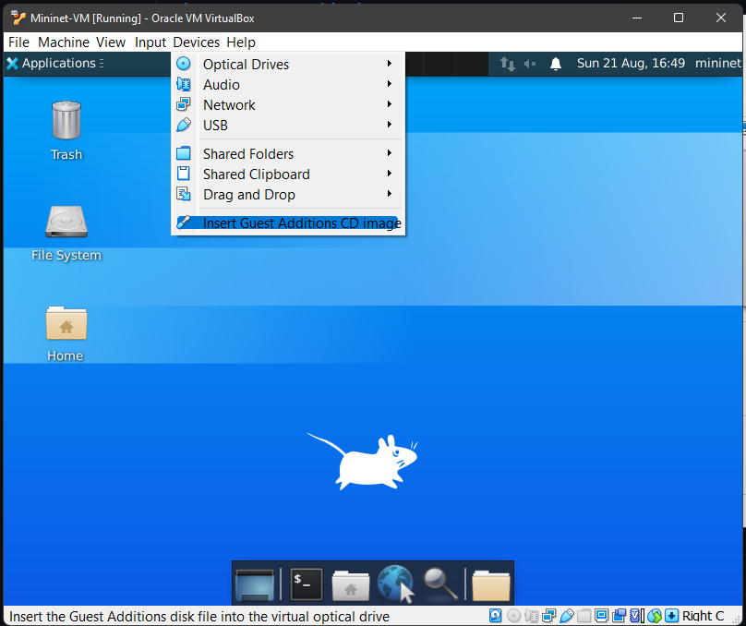
- Insert the Guest Additional CD (as in the screenshot above). You will see a CD icon on the desktop in the VM.
  - If an error message indicates that no optical drive is available, you can repeat the optical drive configuration steps above to add one empty drive.
  - In the GUI, you can always use “Ctrl + Alt + T” to evoke a terminal (when you are using a Windows/Linux host).
- Double click the CD to open it up in the File Manager. Right click the blank space and select “open terminal here.”
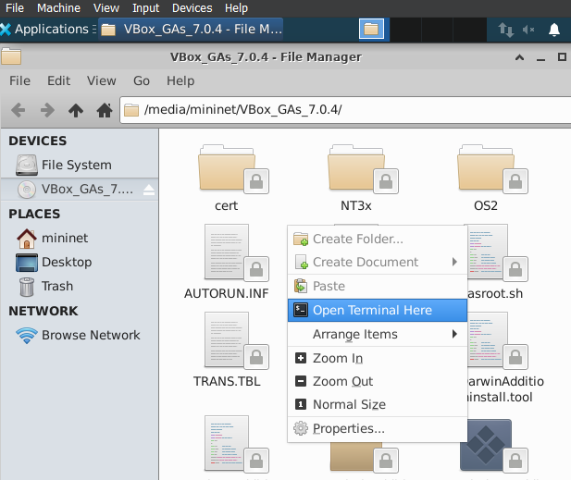
- Run “sudo ./autorun.sh” to install the content.
- Reboot the virtual machine with “sudo reboot” to apply the installed functionalities.
- Then you can adjust screen by simply maximize the VirtualBox Machine window. The resolution will adjust automatically.
After you installed the GuestAdditional functionalities, you can now enable clipboard sharing. In this course, you will need to execute commands specified in the lab instructions. It’s sometimes easier that you can copy and paste the commands to avoid typos.
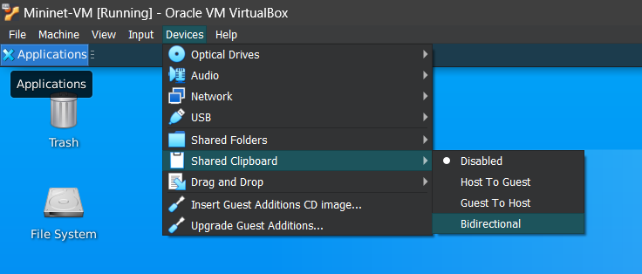
- Evoke an Xfce terminal, in Edit-Preference-Advanced-Encoding, select “Unicode->UTF-8” to make sure that you can paste from the host.
- In Xfce Terminal, you can right click the terminal and select “Paste” to paste the text. If your mouse has a clickable wheel/middle button, you can also click the wheel/middle button to paste the text.
- If you still cannot directly copy and paste into Xfce Terminal from your host machine. Here’s a workaround:
  - Run “sudo apt install mousepad” to install mousepad as a copy/paste buffer.
  - Run “mousepad &” in the terminal.
  - Paste the text from the host machine into mousepad.
  - Copy from mousepad and then paste the text into the terminal for execution.
Deliverable #1. Let’s test the shared clipboard. Please run the following command in your terminal “
for i in {1..10}; do for j in $(seq 1 $i); do echo -ne $i\×$j=$((i*j))\\t;done; echo; done; for i in {1..15}; do for j in $(seq 1 $i); do echo -ne ★;done; echo;done
”. Please paste a screenshot of the results below (no need to include the entire help message). (2 pts)
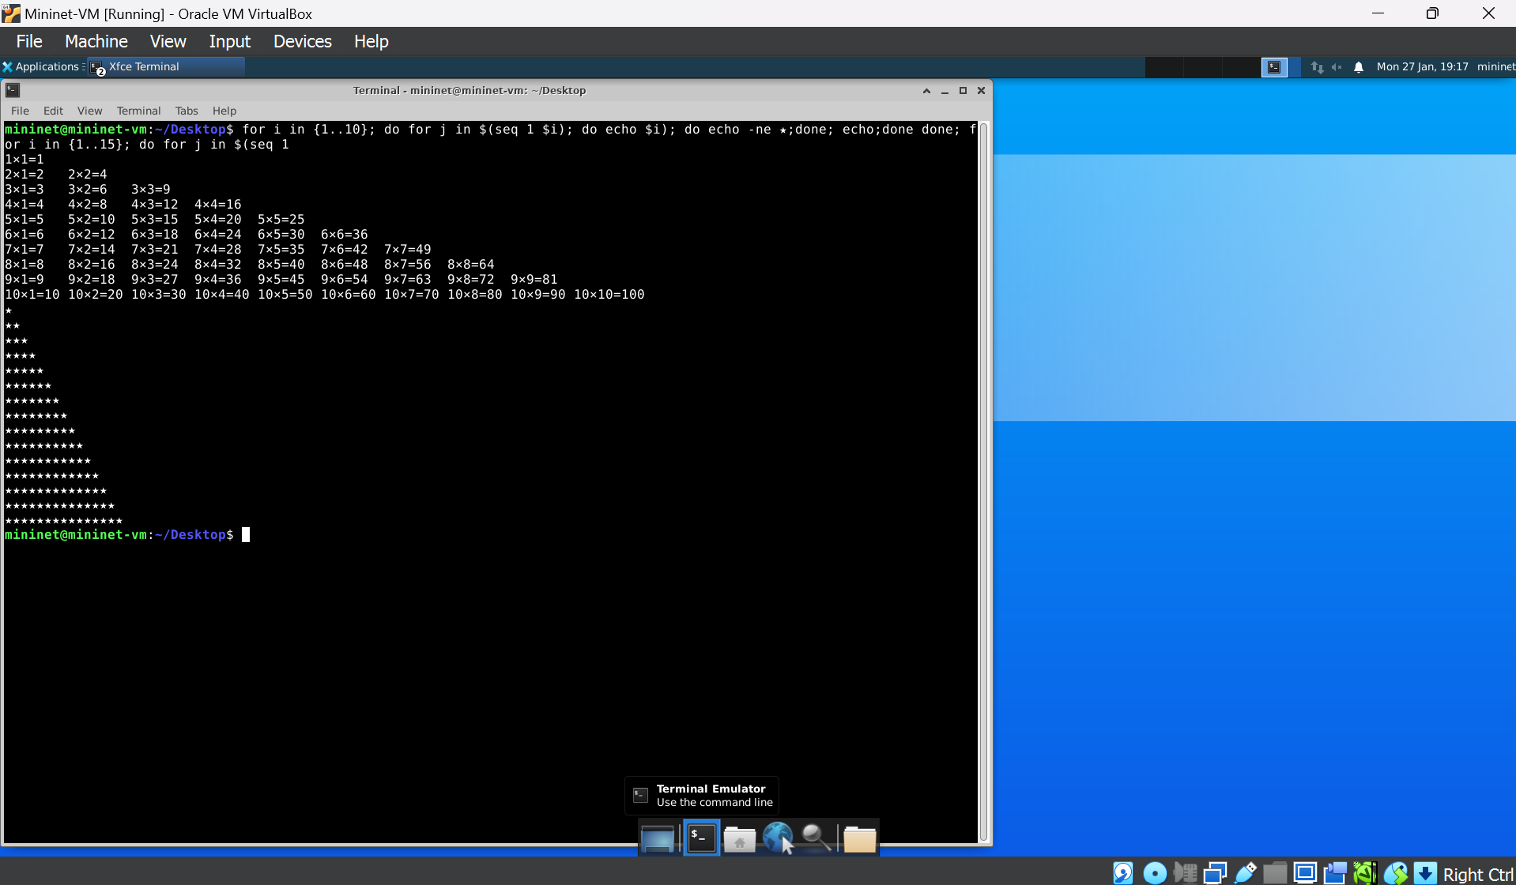

Deliverable #2. After VM set up, please execute “sudo mn -h” in the terminal emulator to retrieve the usage help message. Please paste a screenshot of the window below (no need to include the entire help message). (8 pts)
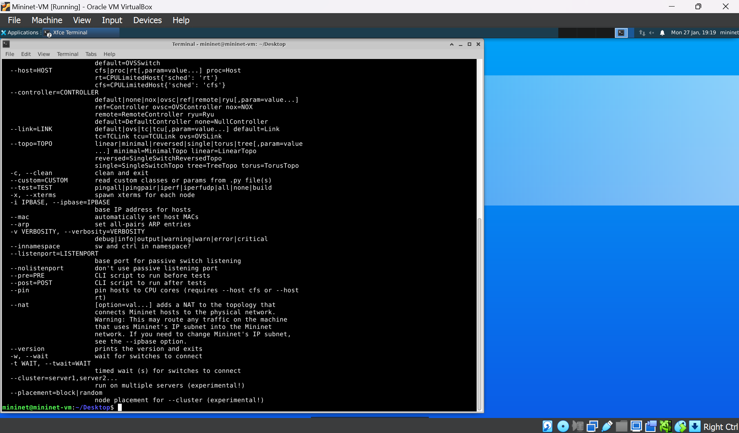

Explore the Default Network (20 pts)
Mininet comes with a default network. Execute “sudo mn” in a terminal to launch the mininet CLI that loads mininet’s default network.
1. Explore network devices
Deliverable #3. Execute “nodes” to display all devices in the network. Provide a screenshot of the result below (2 pt). How many hosts are there (hosts are denoted with “h*”)? How many switches (denoted with “s*”)? (2 pts)
_2_ host(s), _1_switch
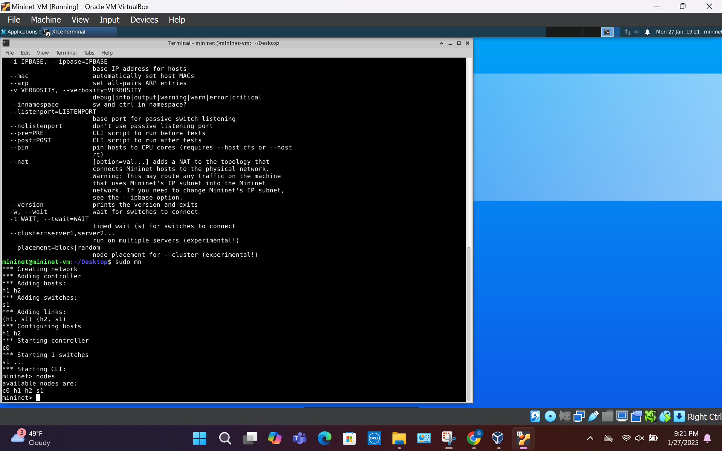

2. Explore network topology
Deliverable #4. Execute “links” to display all connections among devices. Provide a screenshot of the result below (2 pt). Please describe how the devices are connected? (2 pts)
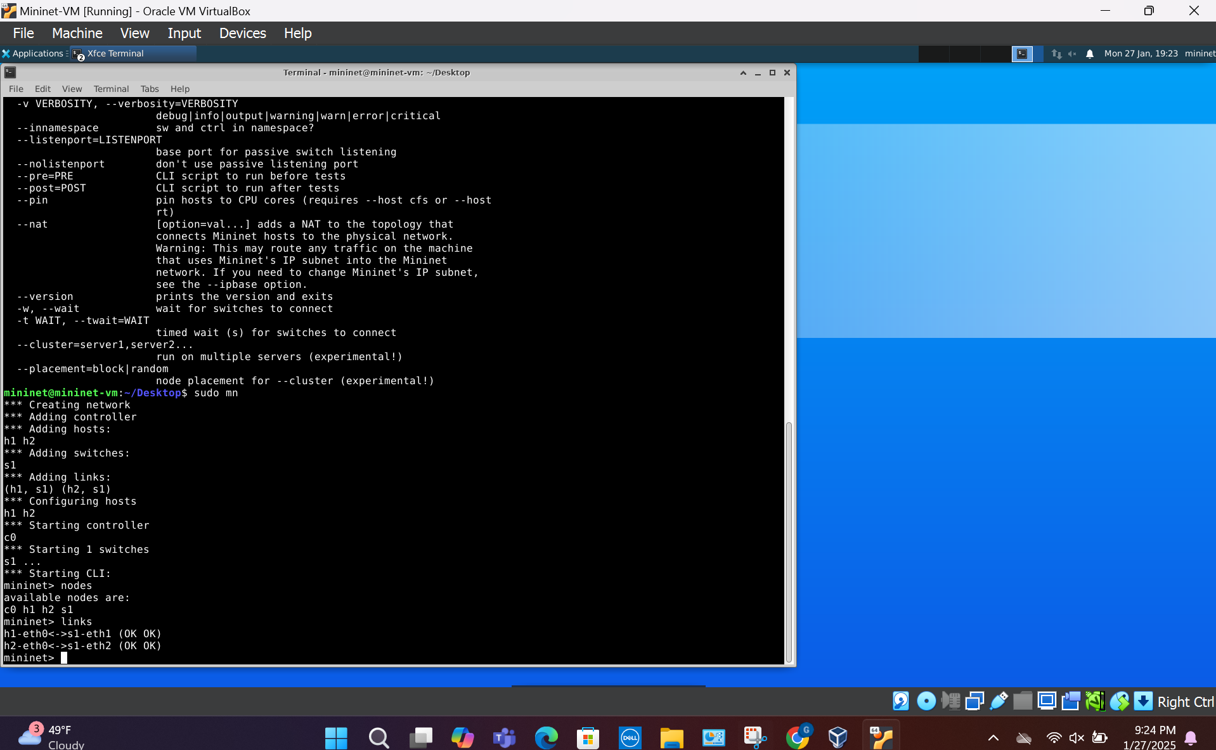
How the devices are connected: The hosts and the switches are connected via ethernet cables. The switch relays data between host 1 and host 2.
3. Interact with a host
Deliverable #5. You can execute “h1 ifconfig” to query the network interface information on host h1. Provide a screenshot of the result below (2 pt). Besides the localhost interface “lo,” what is the name, IP, and MAC address of the other interface? (4 pts)
- Name: h1-eth0
- IP: 10.0.0.1
- MAC: 76:6c:88:b7:d9:f5
Close up:
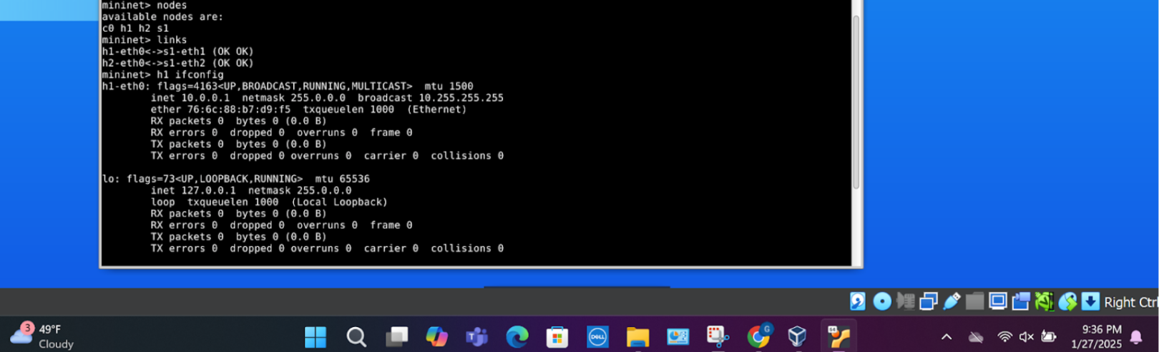
Full photo:
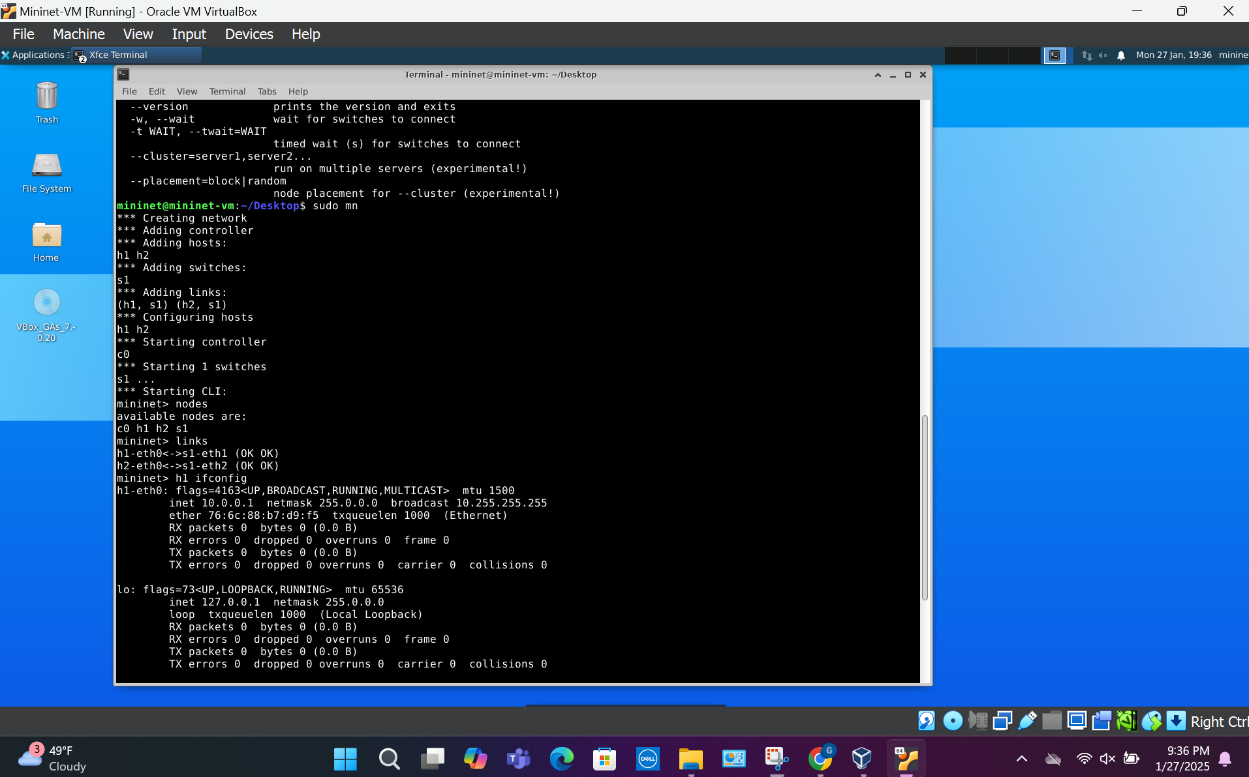
Deliverable #6. Similarly, provide a screenshot of the network interface information of host h2 below (2 pt). Besides the localhost interface “lo,” what is the name, IP, and MAC address of the other interface? (4 pts)
- Name: h2-eth0
- IP: 10.0.0.2
- MAC: e6:50:0d:7a:cc:6a
Close up:
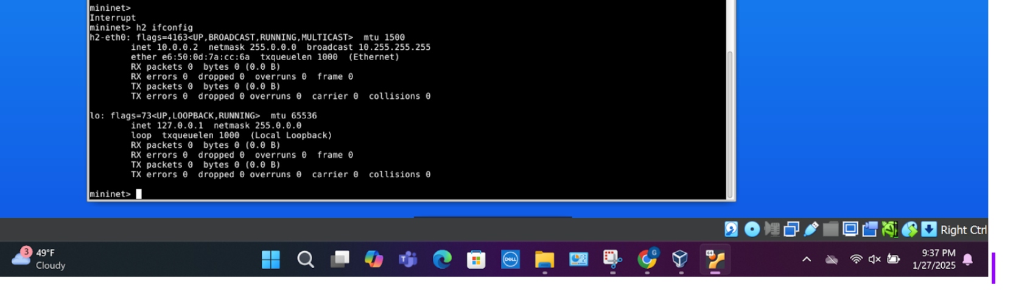
Full photo:
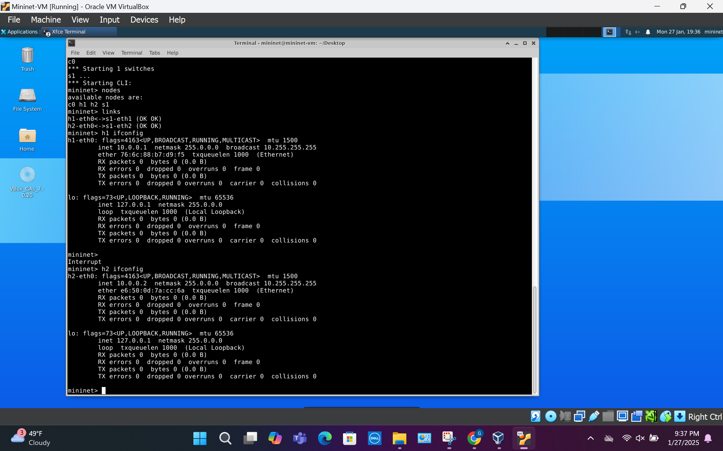

Run “exit” to quit the mininet CLI.
Conduct Initial Wireshark Packet Capture (20 pts)
Make sure that you successfully exit the Mininet CLI. We need to start a new Mininet session. Otherwise, the experiment result will be different.
We will test the network’s connectivity and capture network traffic using Wireshark.
1. Examine the initial environment.
Execute “sudo mn” to launch the default network.
If you are not familiar with what “arp” is, you can read the following manual page: https://man7.org/linux/man-pages/man8/arp.8.html
Deliverable #7. Use the commands “h1 arp -v” and “h2 arp -v” to query the ARP Table of both hosts (h1 and h2). Paste both screenshots of the result below (2 pts). Are they aware of the MAC address of each other? How can you tell? (2 pts)
Command: h1 arp -v:
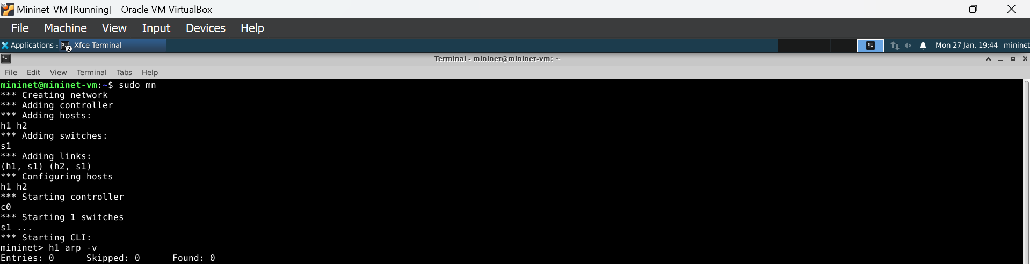
Command: h2 arp -v:
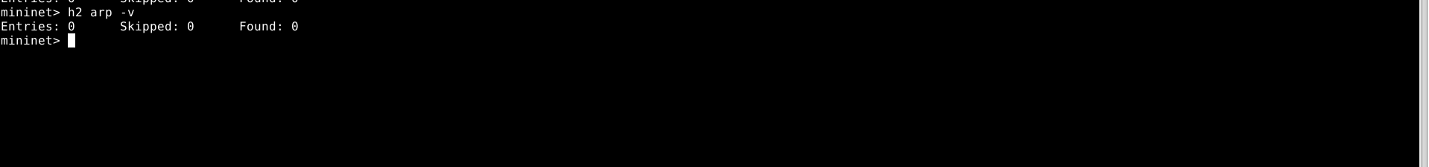
Both commands:
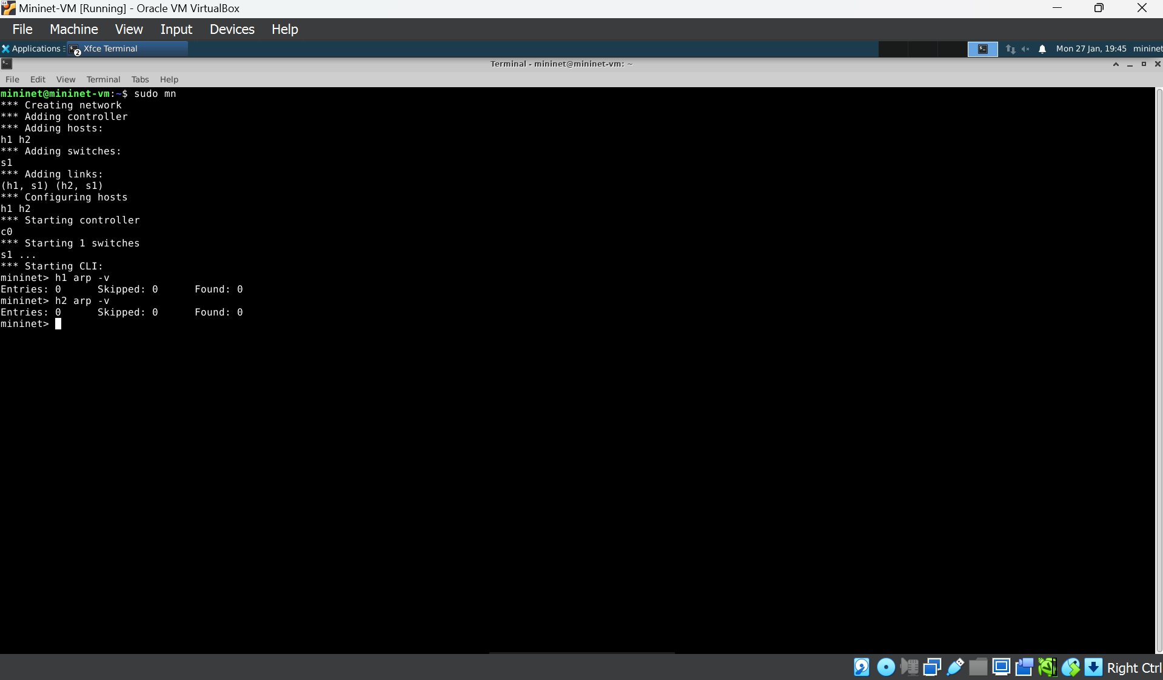
Are they aware of the MAC address of each other? How can you tell? (2 pts):
They are not aware of each other’s MAC addresses. I can tell that they are not aware of each other’s MAC addresses because none of the ARP tables have entries (they are 0).
2. Run Wireshark on host 1 and configure packet capture.
2.1 Execute “h1 wireshark &” (do not miss the “&” symbol) to start Wireshark in the background (i.e., detach the program from the CLI) on host 1. Ignore the start-up warning.
2.2 Select the network interface that you want to monitor (here “h1-eth0”) and click start capture (the green fin icon).
3. Experiment
Deliverable #8. Use the command “h2 ping -c 4 h1” in Mininet CLI. Here, h2 will ping h1 4 times. Paste the screenshot of Wireshark after the command is finished. (2 pts) Then you can stop Wireshark capture (the red square icon).
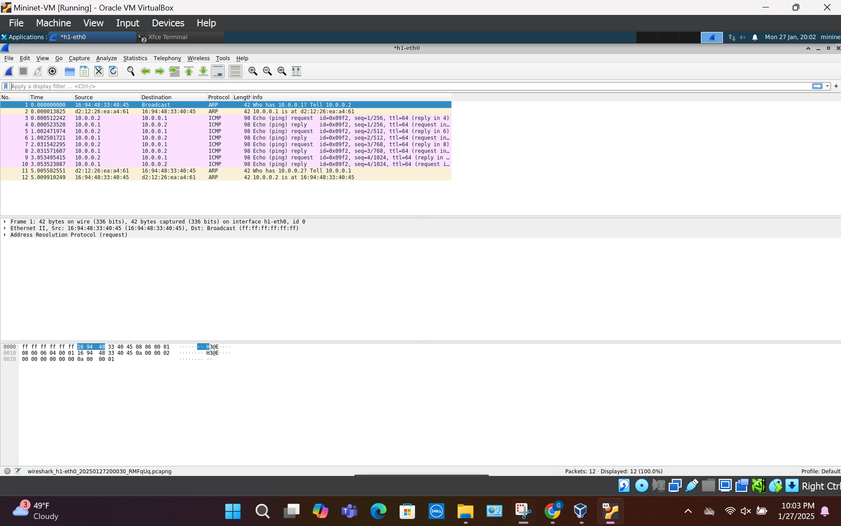

What are the first two packets? What do they do? Which host requests what information? (2 pts): What response does it get? (2 pts):
The first two packets utilize ARP protocols. They are 42 bytes.
- Packet 1 is an ARP request: The host with the IP address 10.0.0.2 requests "Who has 10.0.0.1? Tell 10.0.0.2". It is requesting the MAC address of host 10.0.0.1.
- Packet 2 is an ARP response: The host with IP address 10.0.0.1 replies with: "10.0.0.1 is at d2:12:26:ea:a4:61" (stating what its MAC address is).
Select the first ICMP packet. What is the packet length of this ICMP packet? (2 pts)
The length of the packet is 98 bytes (784 bits), as shown in the photo below.
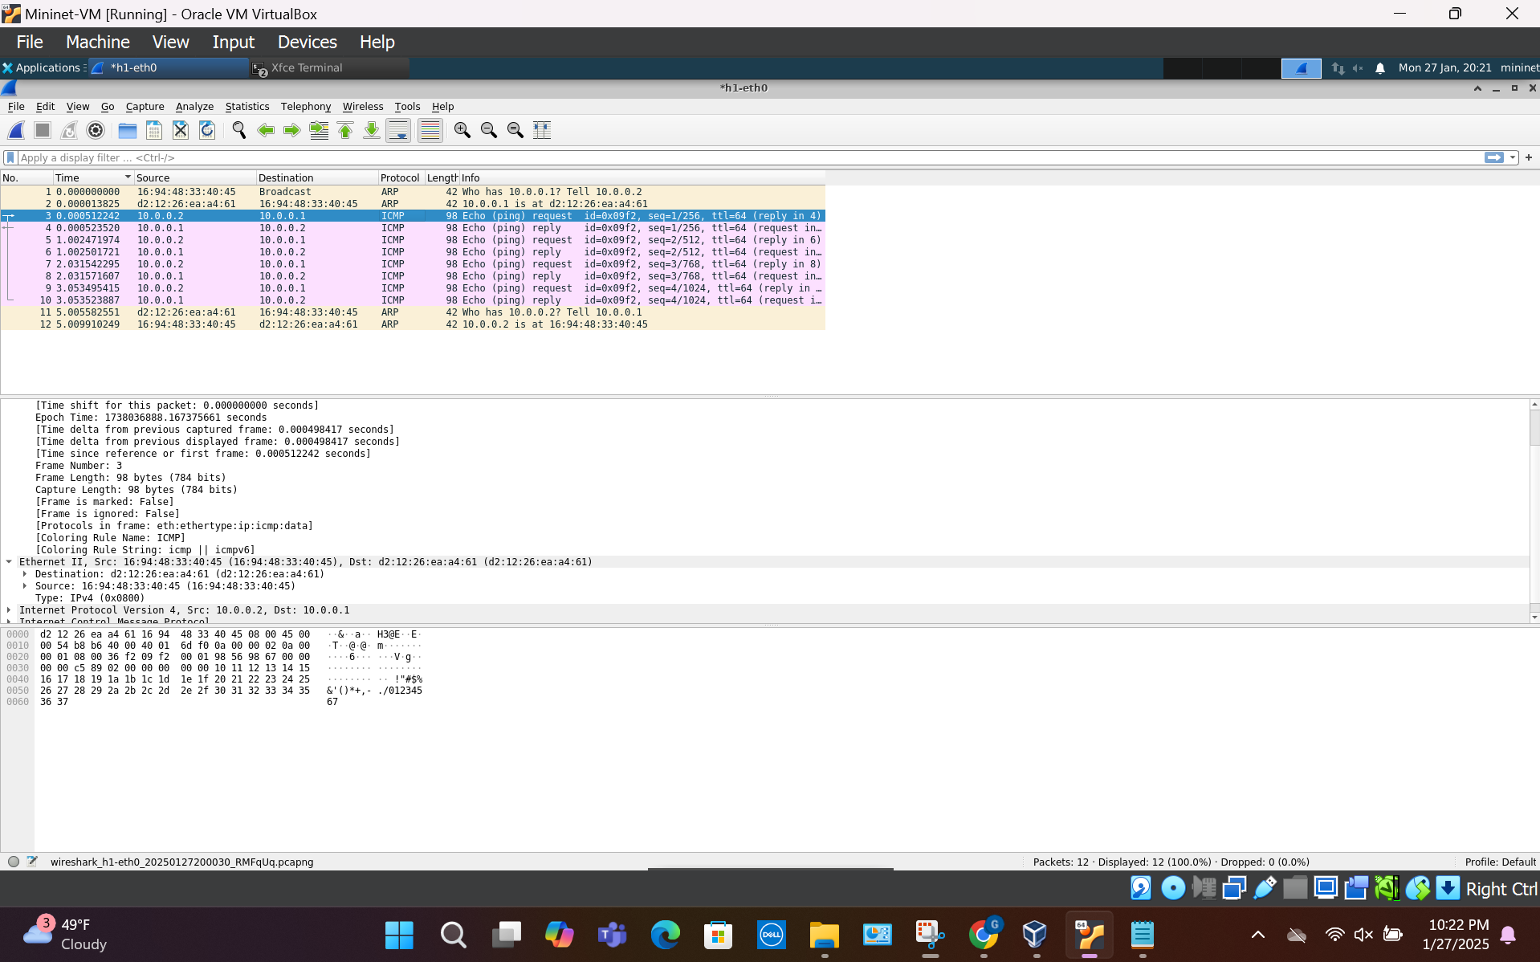
Provide a screenshot of the “Packet Details” panel (the panel in the middle, under the packet list, and above the binary details). (2 pts) Please describe what protocols this ICMP packet uses besides the Internet Control Message Protocol (ICMP). (2 pts)
As shown in the photo below, the protocols that the packet utilizes other than ICMP is Ethernet II and IPv4.
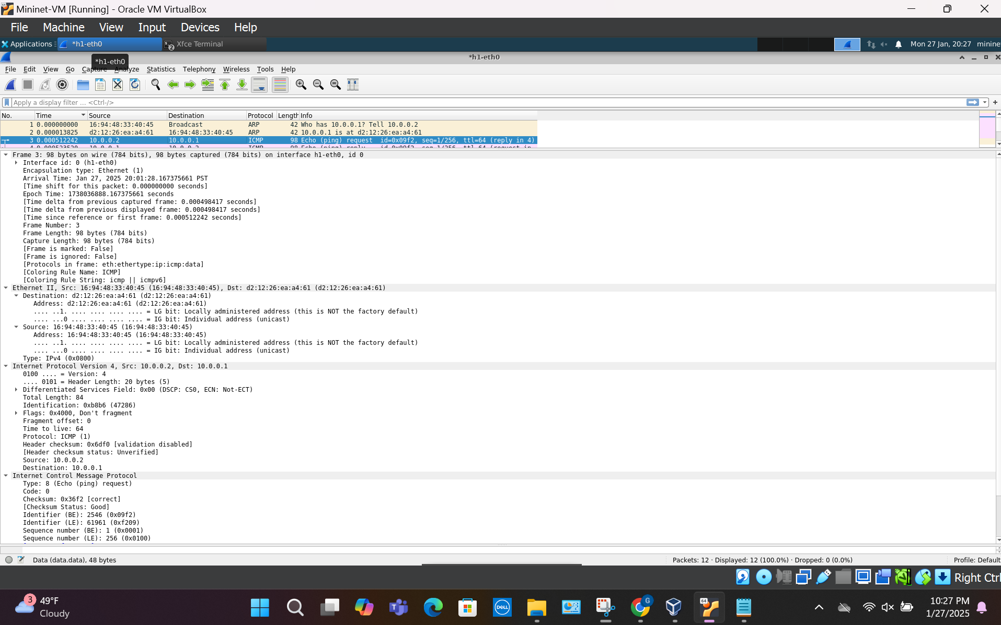
Query the ARP tables on h1 and h2 again (as in Deliverable 7) and provide the screenshots. Are h1 and h2 aware of each other’s MAC addresses now? What is recorded in the ARP tables? (2 pts)
They are aware of each other’s MAC addresses now. This is because both of their ARP tables are filled in with their IP addresses, MAC addresses, and more, as shown in the photos below. The tables state it found 1 valid entry and skipped 0 entries.
Command: h1 arp -v:
Command: h2 arp -v:
Both commands:
